**“Roll Dice game” web application project by Halberg Yaroslav**

**Introduction**

I have developed “Roll Dice” web application. The main purpose of the game is to imitate the dice shaking game. The player has a button “roll dice” and after every click the two random dice values are shown. In addition to the dice images the text is shown: “You rolled <dice 1 value> and <dice 2 value> (Sum <dice 1 value + dice 2 value>)”. The target of the player is to get two equal dice values.



In the case of getting two equal dice values, the special text addition is shown:   
“Doubles! You win!”. In addition, the number of dice counts is calculated, so the player can try to achieve the best possible result.

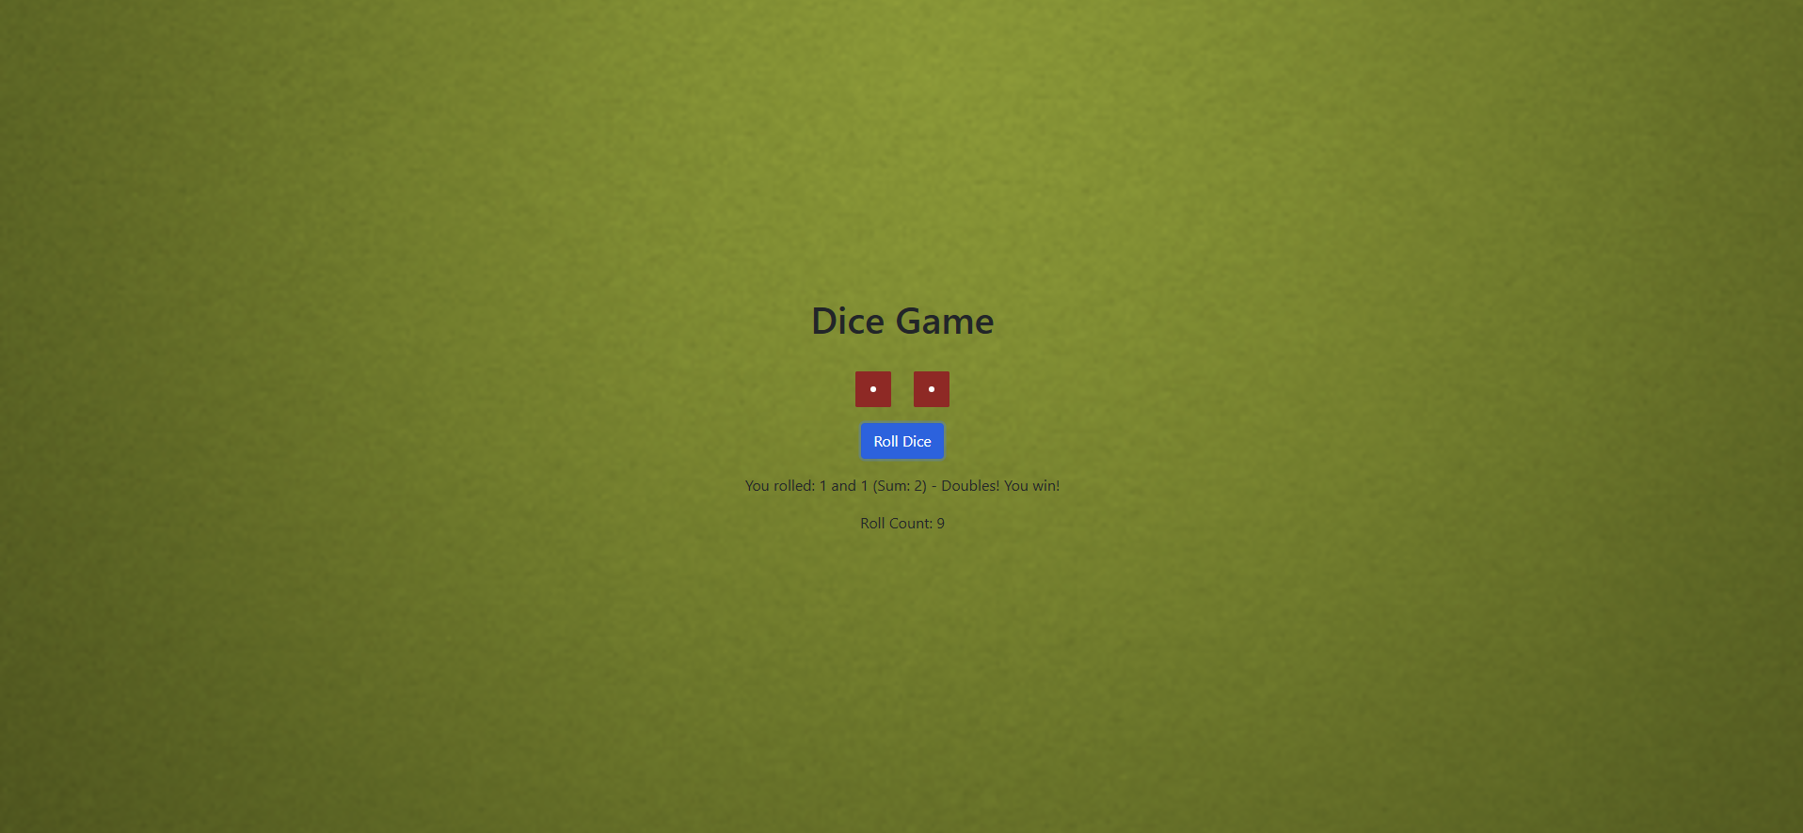

**Development process**

I have developed this web application using React tool. Because I have used it for the first time, I faced some challenges with downloading appropriate software. So, I have downloaded:

1. Node.js from the official provider page
2. Npm using the command line prompt “npm install -g npm”
3. React-create app tool for the basic react app setup.



The main challenge I have faced – were images. In my project I have a batch of images: different roll states, background, and favicon. So, the challenge was to get links to these images from the main html file – index.html and to link supportive files as index.css and index.js. So, I have used the following file structure:

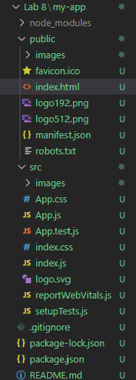

In addition, I transferred part of css style code into .html file:

**Code description**

The most attractive part of the project is the roll dice function. It uses the following algorithm:

1. It is triggered after the “Roll Dice” button click
2. Two random numbers between 1 and 6 are selected
3. Roll images are called due to the number being selected, because dice with the value 6 has a roll image ‘dice6.png’
4. These numbers are used in the text
5. The winning condition is checked – and additional text is shown if needed
6. The number of attempts is increased by one

